1.启动类开启缓存功能@EnableCaching

@EnableCaching 启用缓存注解（写在配置类(@Configuration)或者启动类上面）

2.在对应的controller上加@Cacheable(cacheNames = “xxx”,key = “#xxx”)

@RequestMapping("/hh/{a}")

@Cacheable(cacheNames = "myc",key = "#age")

public String readFile3(@PathVariable("a")int age){

System.out.println("看看执行了吗");

return age+"111";

}

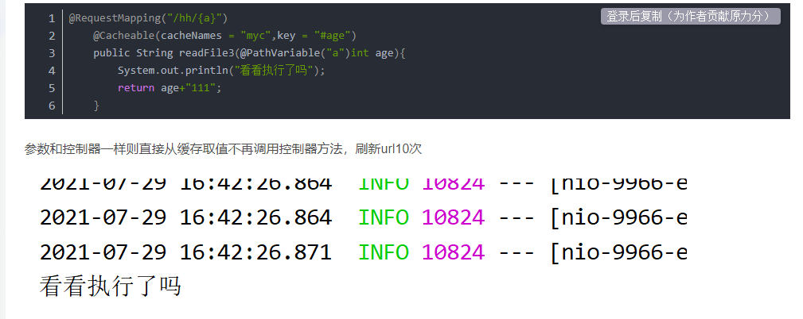

参数和控制器一样则直接从缓存取值不再调用控制器方法，刷新url10次

